Ian Galler

Advanced Web Development

Professor

16 September 2018

Report Overview

https://igaller.github.io/IT4203/

The purpose of this Milestone project/assignment was developing a set of code that would read a json script and print it onto an html webpage. In order to read the json file, JavaScript and the jQuery library were used to complete this process. I originally took Web Development I which used CSS and html, so using JavaScript and json was a new concept to learn. I have used java but not JavaScript. It took a bit to understand how to create a script code that reads the json file and prints the information. HTML and CSS are then used to process that information and organize it into a more readable.

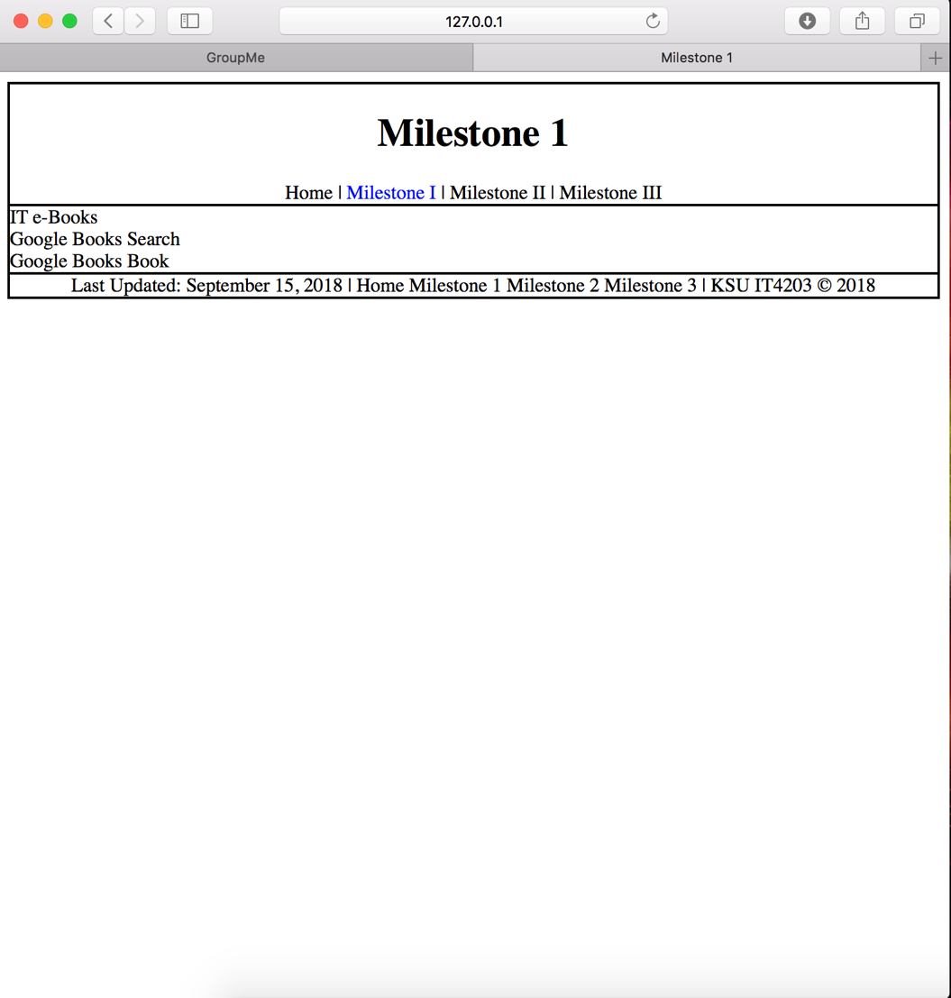

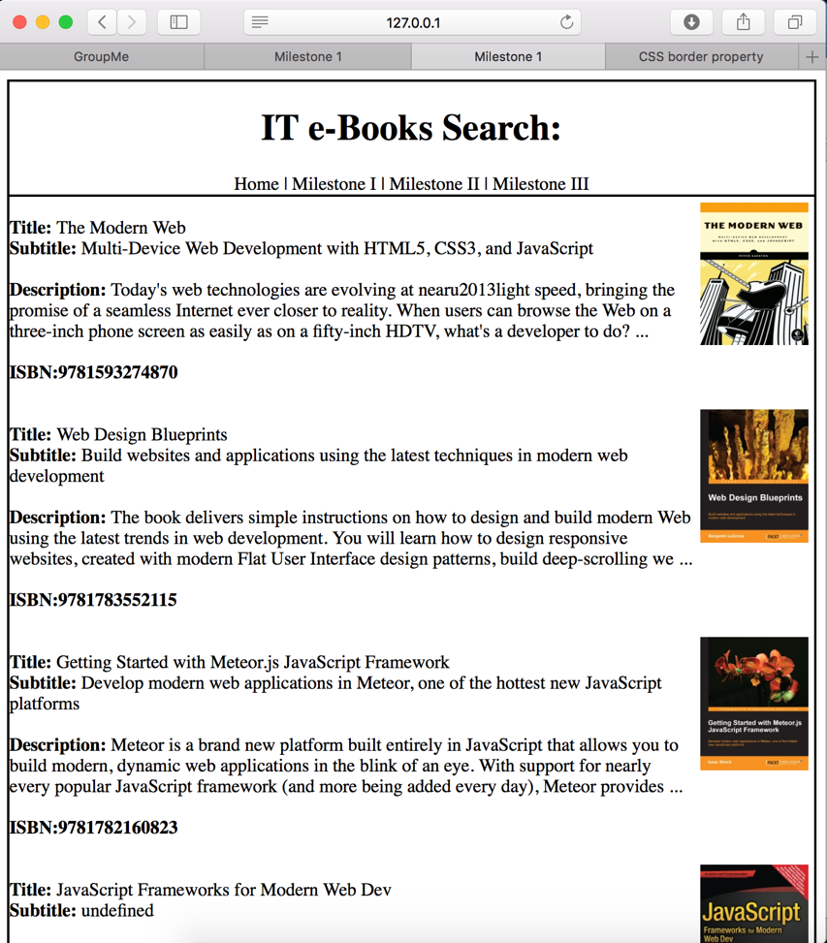The IT-eBook Search json information was a list of books with their information on it. This included the title, subtitle, author, description and both ISBN numbers. I took the information and printed it in about the same order. Since everything did not need to be fancy I grouped the information together and just displayed it as it was on a basic html page. CSS was used for the font and placement of the images. The images were given padding, so they were not directly touching the site borders.

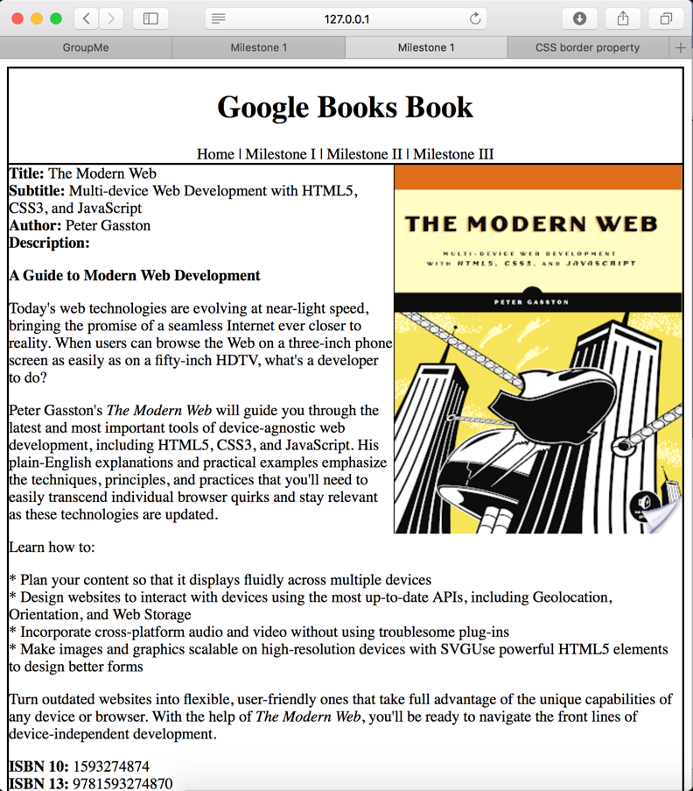The same thing was done for the Google Books Book information as well. The only difference is the json file was for the information about a specific book search. The information was a little difficult to go through because I needed to decide what was most important to be displayed on the website. The file has the main information set to the top and the book description below. All information was formatted and designed in a similar order as the json’s information.

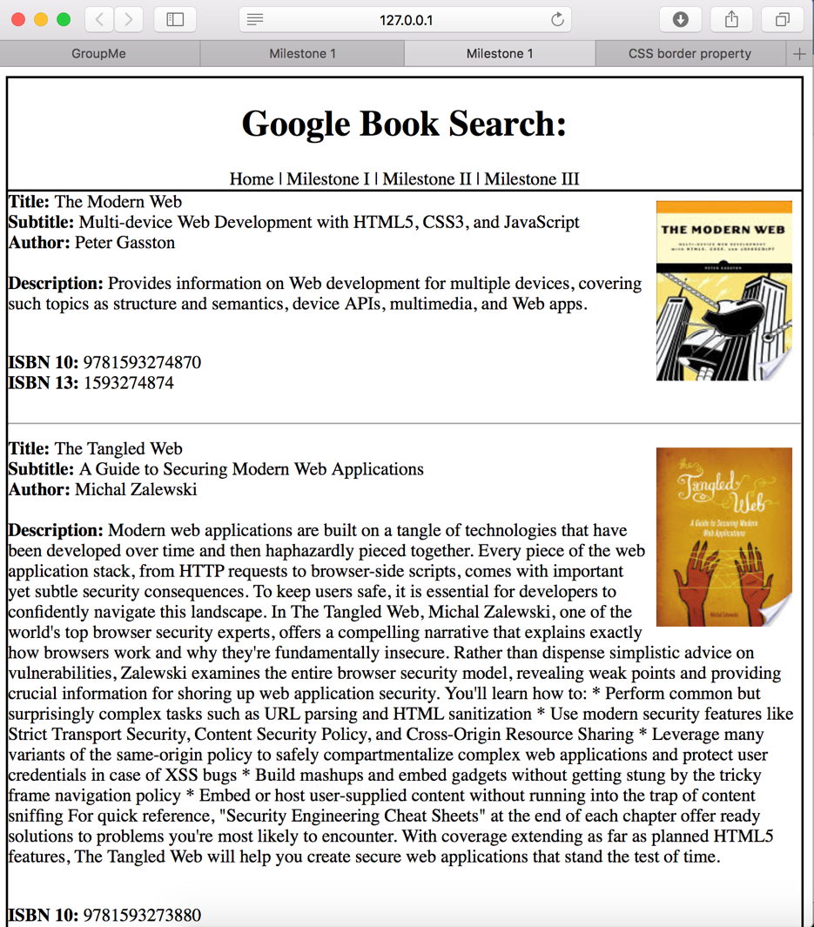

With Google Book Search, I saw it as a similar group of information to Google Books Book and formatted it to a similar idea. Extra information was provided to show that both Books Book and Book Search are different in a few other aspects. I decided not to add maturity level, page numbers and a few other data because not many users look at it. I also was not sure where I would exactly put the information and I am not sure I currently know where I would have put that information.

Seeing as this is my first-time using JavaScript, jQuery with html and CSS methods, it is fairly sloppy looking or at the most basic organization. Over time and throughout the semester I am sure it will be